How to run the Agrodem – Creating Base Grid plugin

Before opening the plugin make sure that the necessary files are loaded into your current QGIS session. You will need four datasets for the plugin to function correctly:

1. **Administrative boundaries**
2. **FAO agro map**

In order to use the plugin:

1. Open the plugin from the **Plugin** menu. The name of the plugin when installed will be Agrodem – Creating Base Grid
2. The following window will open up:

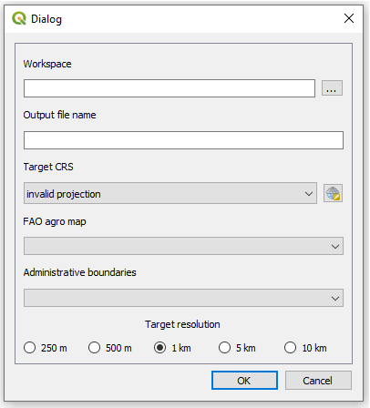

Figure 1. Plugin GUI

1. In the field named **Workspace**, click on the three dots on the right hand side of the field and navigate to an empty folder.

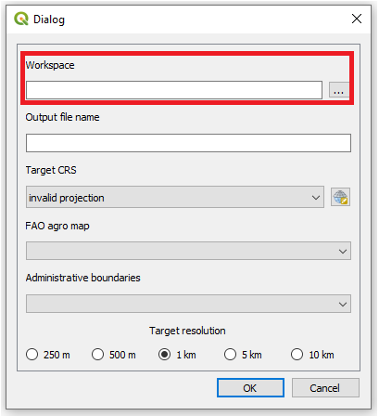

Figure 2. Select workspace.

1. Enter the name of the output file name in the next box.

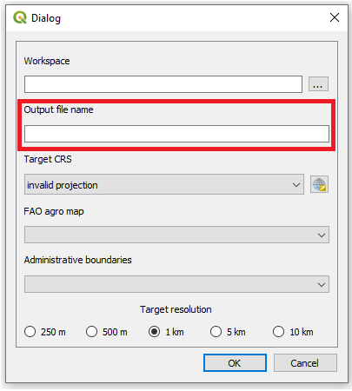

Figure 3. Enter the name you wish the output file to have

1. Next chose the **projection system.** Make sure that the projection system is in a linear unit and that this linear unit is meters.

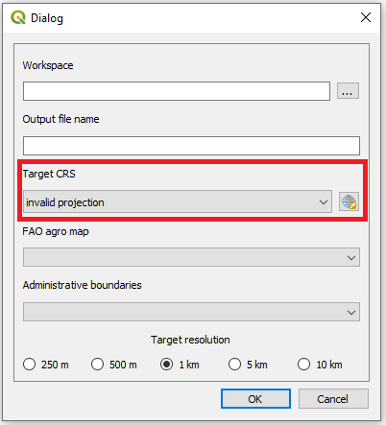

Figure 5. Select projection system

**NOTE: When selecting the projection system the following window will open up:**

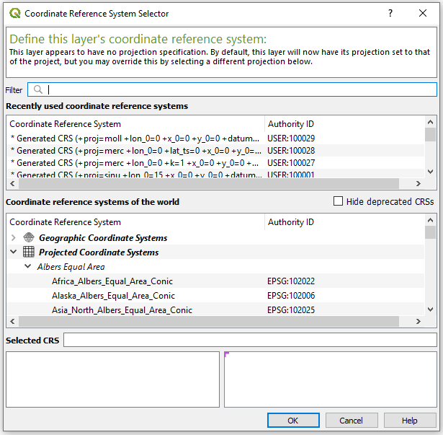

Figure 6. Projection selection window

**To find the coordinate system that is appropriate for your study area please visit** [**http://epsg.io/**](http://epsg.io/) **and search for your area of interest.**

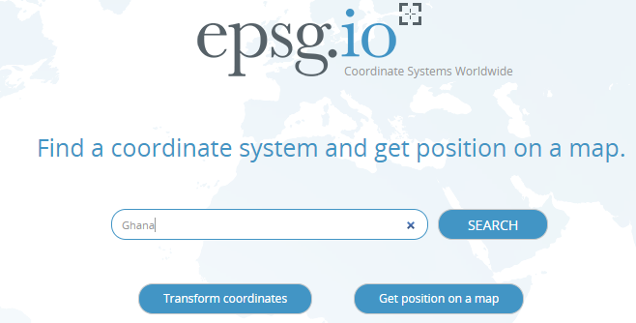

Figure 7. Go to epsg.io and search for the country you want to reproject

**This will present you with a list of coordinate systems suitable.**

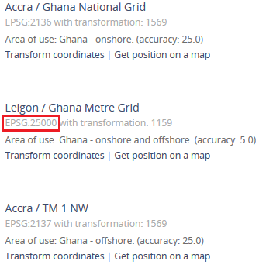

Figure 8. You will get a list of different coordunate systems that fit with your study area. Choose one and note its EPSG code.

**Next, come back to QGIS. Click on the icon next to the field and check the EPSG code received from the webpage. Choose one where the unit is in meters and the red box covers the whole area you are working with.**

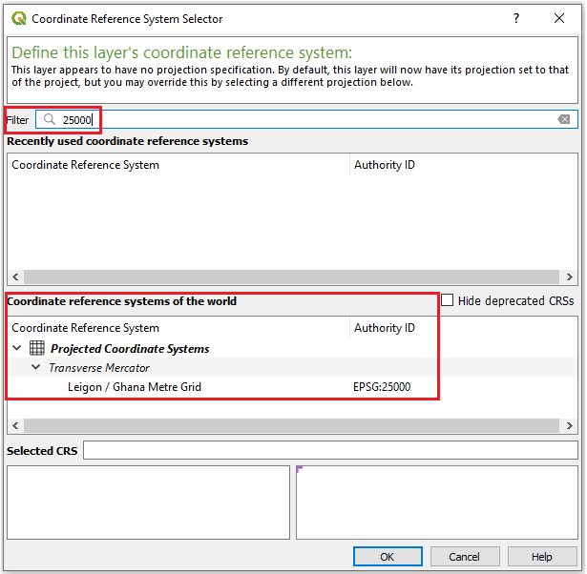

Figure 9. Enter the coordinate system you have chosen in the field. Make sure that the unit is meters (lower left box) and that the red area covers your study area (lower right box)

1. In the next four boxes select the appropriate datasets.

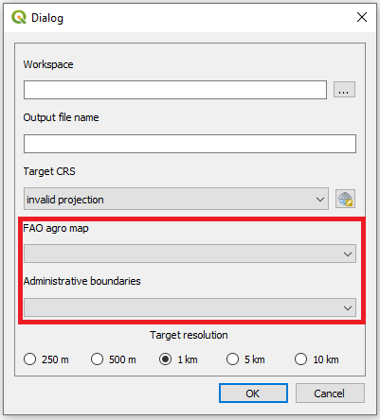

Figure 10. Enter the datasets used for the creation of the csv file

1. Select the desired output resolution, the higher the resolution the longer it takes to run.

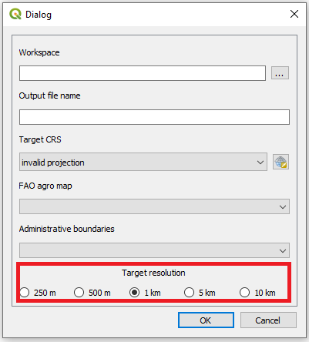

1. Plugin may take some time to run depending on the size of the study area. During this time QGIS can not be used. For the example a csv file with 60,000 rows takes approximately 10 minutes to prepare